- Install Apache Tomcat (I use version 7: http://tomcat.apache.org/download-70.cgi).
- Download lattes version of the BRBWeb project.
- Configure your local file BRBWeb\local.properties from Eclips according follow screenshot:
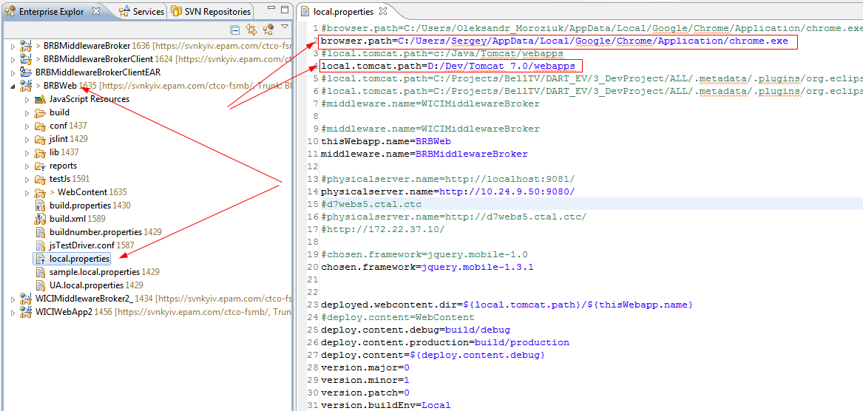
Where:
browser.path - path to Google chrome browser
local.tomcat.path – path to the Tomcat directory that contains web applications to be deployed on virtual host. Path to the directory can be changed, see this article: http://tomcat.apache.org/tomcat-7.0-doc/config/host.html.

- Build and deploy project using BRBWebApp Ant build script.

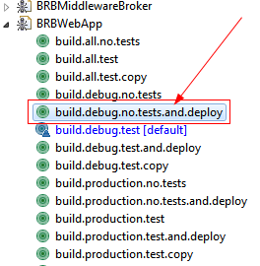

VERY IMPORTANT: Select “build.debug.no.tests.and.deploy” option.

- Allow cross-domain requests in chrome. Right click on Google Chrome shortcut , select “Properties ” and add
“--disable-web-security” key

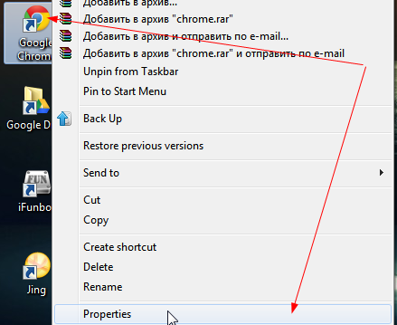
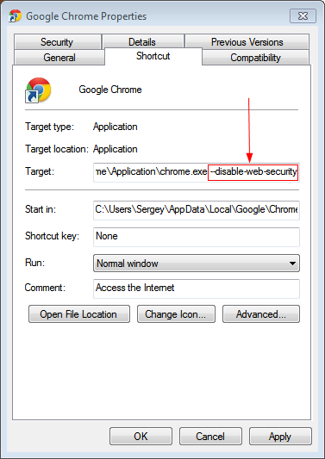
- Initiate VPN connection
- Load page by follow URL in Google Chrome
http://localhost:8081/BRBWeb/ApplicationStartPage.html

